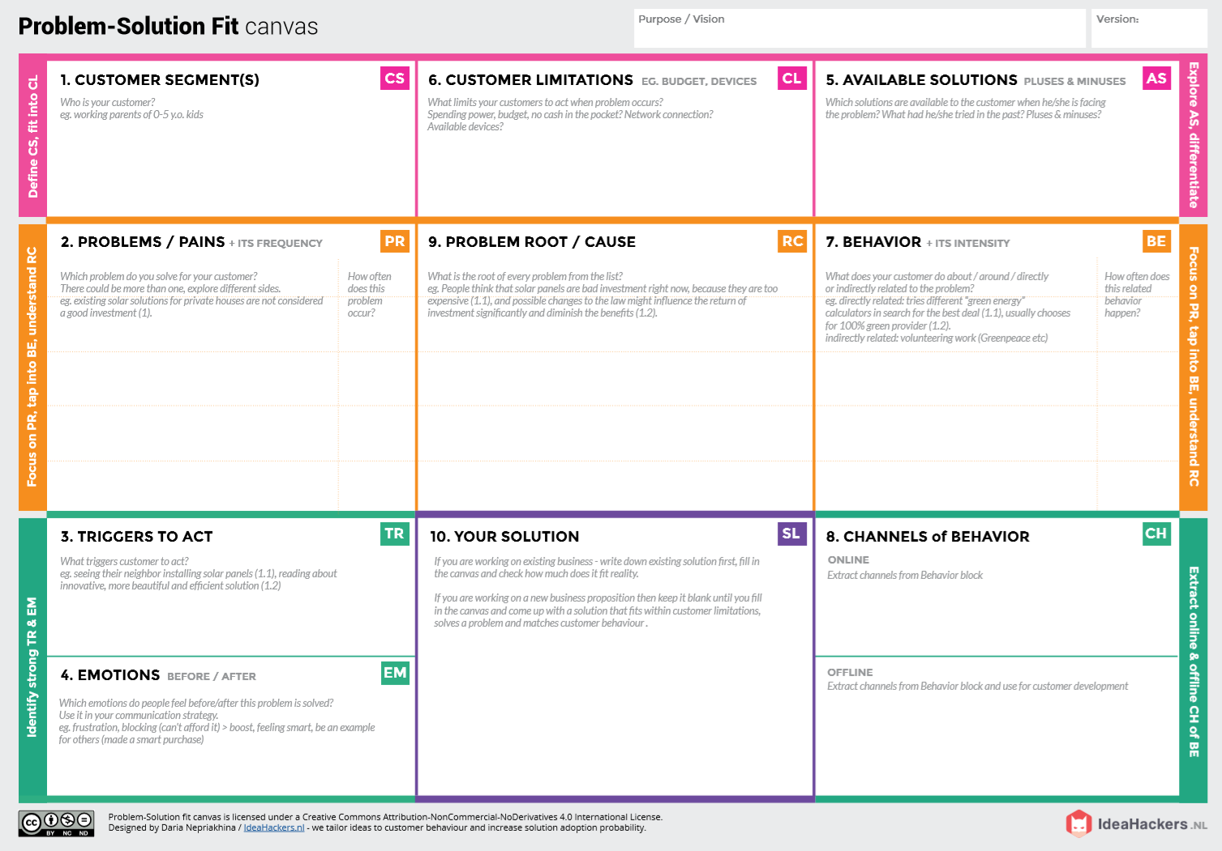**Project : IOT Based Smart Crop**  **Project Design Phase-1 Solution Fit** **Team ID**:**PNT2022TMID05601**

**OFFLINE**: The control action is taken by the farmers to monitor the farms.

**ONLINE:** The Data send through application for the farmers to know about the farms.

* **Direct related**: Tries to find a solution to prevent this problem
* **Indirect related**: Located in rural where internet connectivity might not be strong enough to facilitate fast transmission speeds.
* Monitor different parameters and mobile or web application make easily to farm the crop field .

***“ IOT based Smart crop protection system for agriculture” !!***

It help farmers grow more food on less land by protection crops from pests, diseases and weeds as well as raising productivity per hectare.

* If temperature ,PH level ,humidity & light intensity makes the serious cause for the environment.
* Farmer affected by less productivity which will affect in their profit.
* High adoption costs , security concerns
* Not aware of the implementation of IoT in agriculture.
* It’s difficult to monitor and control
* Ain’t known if the application doesn’t work properly.
* Farmers ! Who is not near their field
* Create opportunities to lift people out of poverty in developing nations. (Over 60% )

**BEFORE**: Finances, Heavy work overload and conflict in relationship.

**AFTER**: It will easier to make more yield in field

**Protection System for Agriculture**